1. Install Terraform on your PC

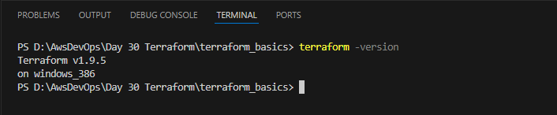

1. Execute all the templates shown in video.  
   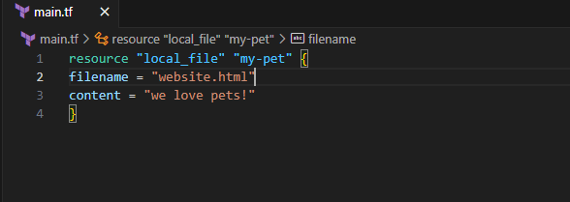
2. Note down below points,
3. Terraform Init

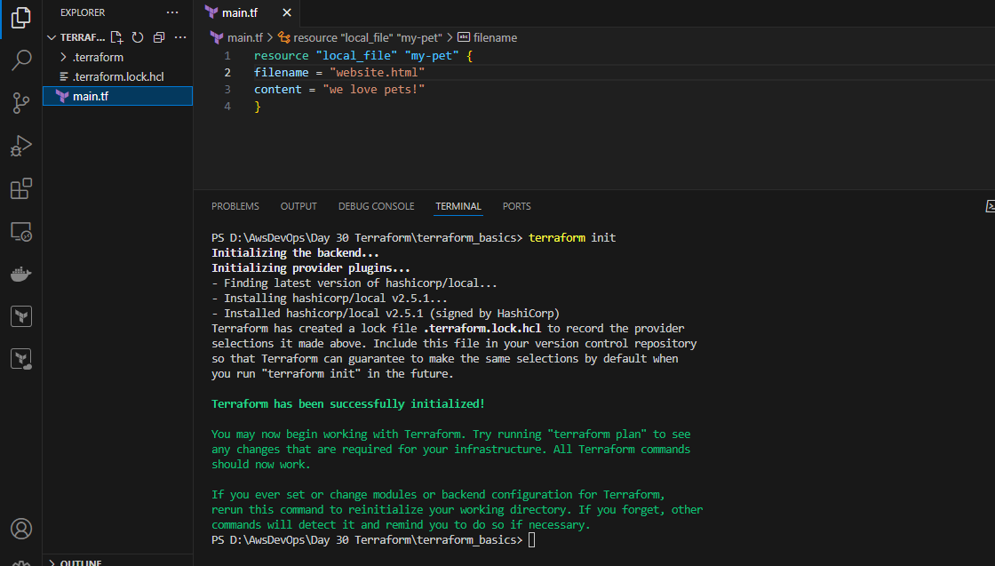

Adjusted the formate of my code

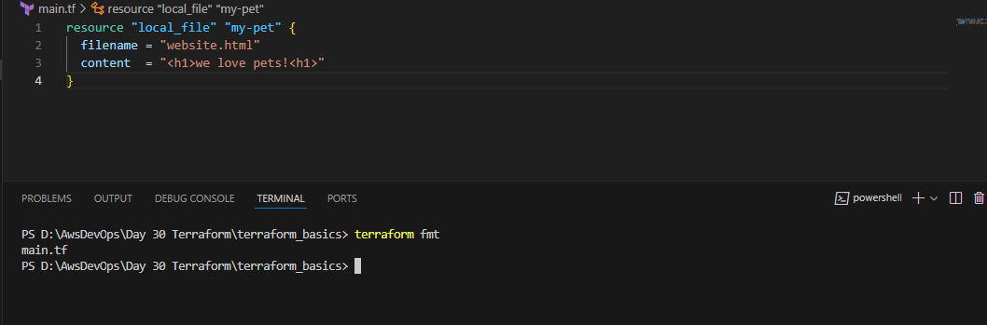

1. Terraform Plan

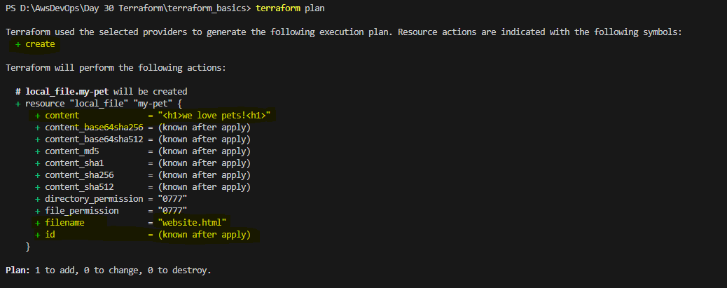

1. Terraform Apply

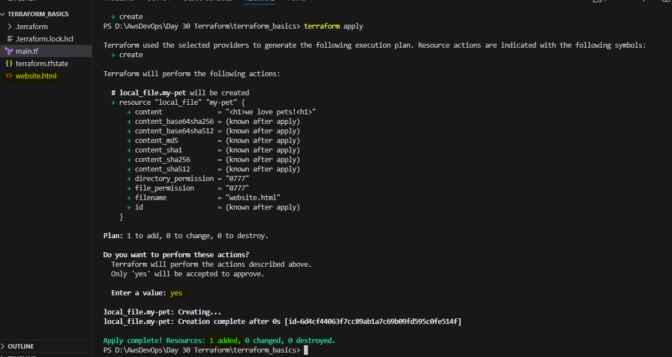

1. Terraform Provider. (Added a provider)

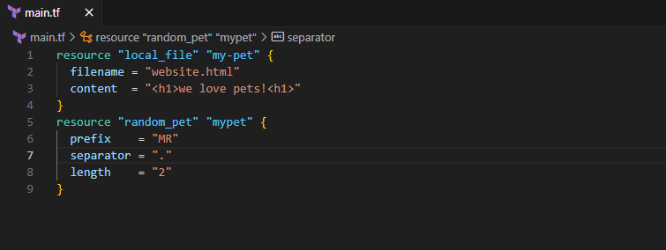

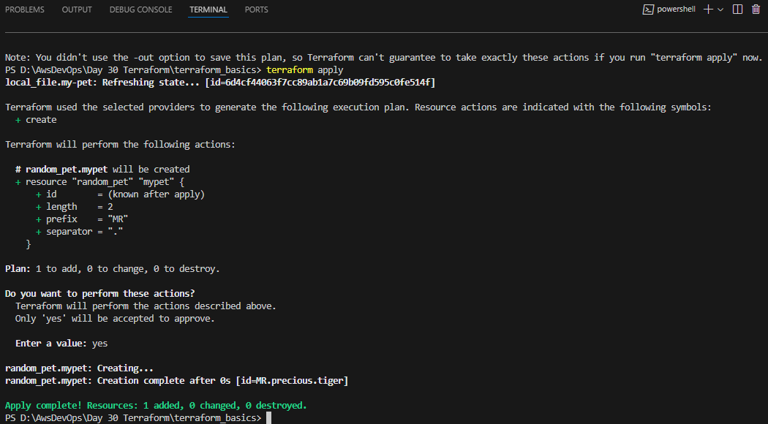

1. Integrate a sample Terraform template in jenkins.  
   Installed terraform on Jenkins CLI also added Terraform plug in in Jenkins UI: 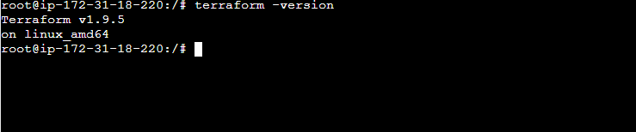

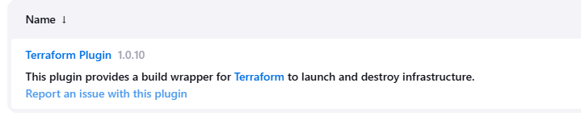

Created a sample Repository in Jenkins:

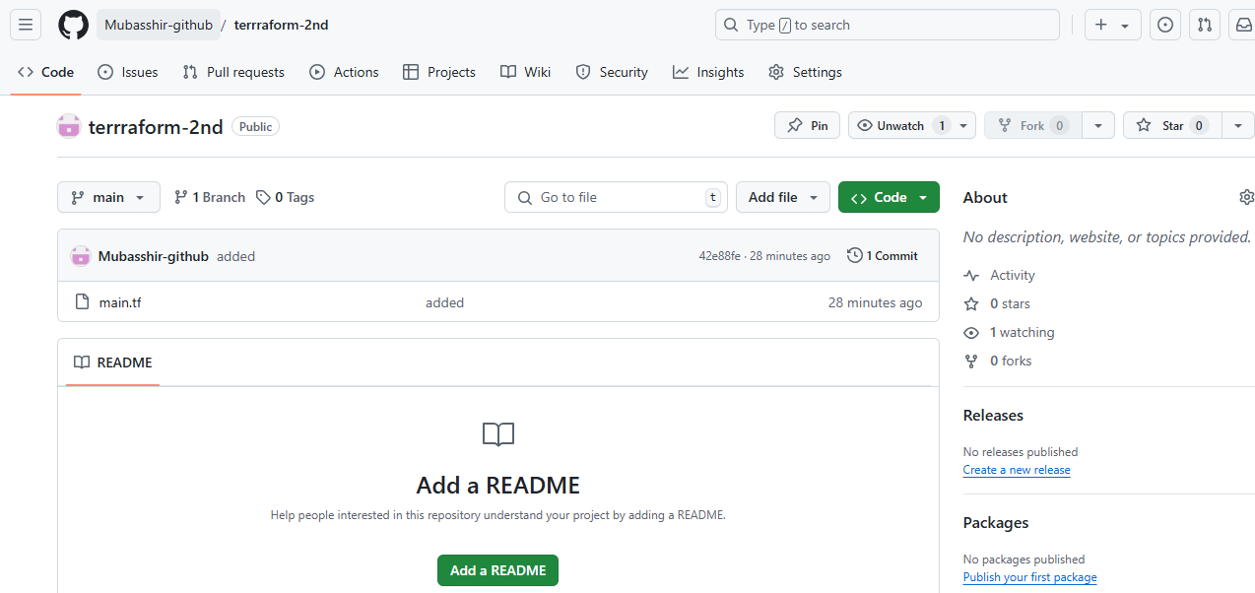

Created a shell script to execute the terraform commands:  
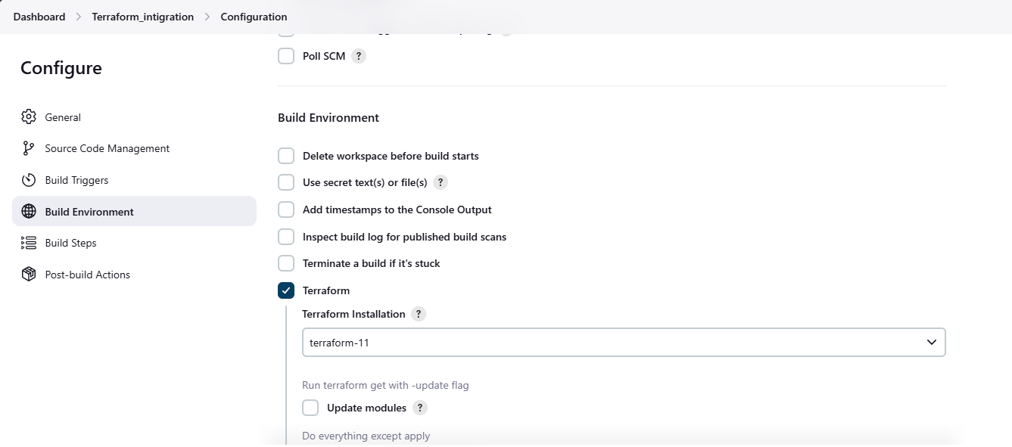  
script execution:

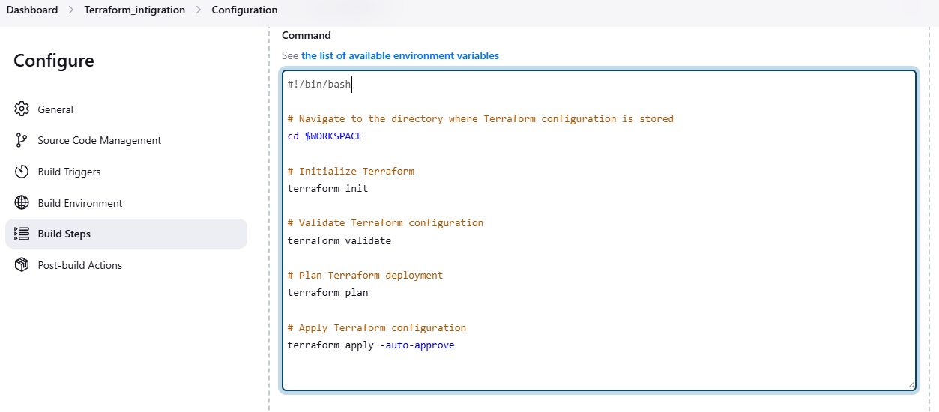  
The job has created the terraform files and integrated as well:  
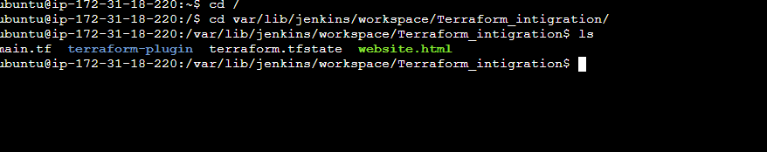

Jenkins output:

